‘Fletcher and Nicholson’ is a designer fashion label who uses e-commerce to sell its products, maintain e-commerce databases containing all of its product images, videos, product descriptions and the back-office information such as stock, orders and customer account information.

* Explain the need to back up and archive the data and the procedures required to do this. (8 marks)

Answer:

It is needed to archive information in case a security breach happens or any situation that can compromise important data. There will be a copy of the data on a separated storage device that can not be accessed through the system normally in case it gets hacked or corrupted. Since the data is backed up there is no need to recreate the data and start from beginning, for e-commerce companies like ‘Fletcher and Nicholson’ losing their data could mean compromising their personal information which could result in lawsuits filed against the company and a loss of reputation.

They should archive at the end of everyday to ensure new items or orders from customers, as well as removed items and the stock which is kept up to date. Which is important so that the company doesn’t sell items that are out of stock and can’t be supplied, it also lets them keep a track of their stock at the end of the day and they can know if they are running low on stock and need to acquire more products. They can also cross check their list of products with their backup if there is an error suspected.

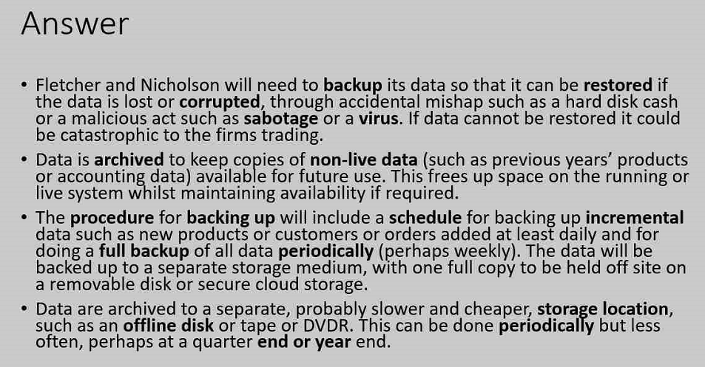

The multi-floor shopping mall intends to add custom built interactive information kiosks at strategic points in the centre.

Discuss the types of user interface it should use. (4 marks)

The shopping mall should use user interfaces at strategic points around the centre.

The shopping centre should use a graphical user interface (GUI) instead of a command line interface (CLI) as it is more user friendly and will be easily accessible by all people, a CLI will be harder to use for the general populace as many will not have the required knowledge and training to use it.

A GUI would be more suitable than a menu driven interface as it allows for more functionality such as browsing the web, but this can be used to cause security breaches and people would hog the kiosks and watch videos or take a long time browsing the web.

A forms user interface reduces the possibility of error as it only allows simple input choices such as directions using menu buttons and text input boxes, due to this they cannot access unauthorised parts such as a CLI where the system can be hacked easily.

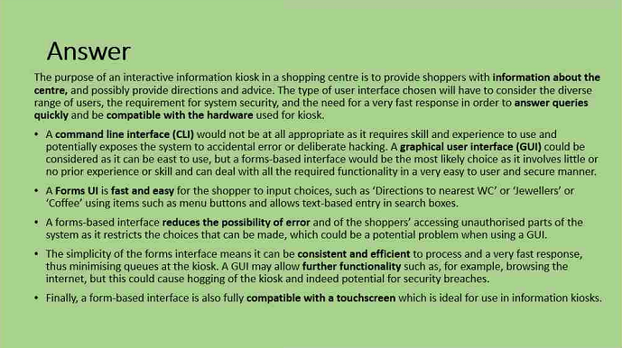

Fruitful vegan restaurant chain is planning a large expansion under the direction of new commercial director bill fence. It has a single computer system in each branch which runs the whole branch operation. The system uses an open source software for all task, running a version of the open source BSD system. Although the system works effectively, Bill has decided that he wants to move the most popular, proprietary system running the standard office he has always used and feels most new recruits will know and understand.

Evaluate Bill Fence’s decision (6 marks)

Bill fence is a new commercial manager who wants to expand the business, it currently uses BSD as the OS on the company computers and he wants to change it to the most popular system and office which he is used to – which I am assuming is Microsoft windows and office – and assumes that everyone will already know how to use it.

This is a good choice as most will know how to use windows but it is not absolute. Someone may have only used computers in the shops and never at home so they could not know how to navigate through windows. Majority of the time though the staff will know how to use it and will have prior experience in working on It, this will boost their work efficiency and will be a lot easier for them to do their work.

Another benefit this change could bring would be more security as Microsoft is not an open source OS and will have better security than BSD, so there is less risk of being hacked or having security breaches.

Windows is also built specifically for this purpose of doing work unlike BSD which is a multi-purpose unrefined OS, so it will be more suited to that purpose and better for doing their job successfully